**1.Introduction**

**1.1Over View**

Business cards are [cards](https://en.wikipedia.org/wiki/Card_stock) bearing business [information](https://en.wikipedia.org/wiki/Information) about a [company](https://en.wikipedia.org/wiki/Company) or [individual](https://en.wikipedia.org/wiki/Individual). They are shared during formal introductions as a convenience and a memory aid. A business card typically includes the giver's name, [company](https://en.wikipedia.org/wiki/Types_of_companies) or business affiliation and contact information such as [street addresses](https://en.wikipedia.org/wiki/Address_(geography)), [telephone number](https://en.wikipedia.org/wiki/Telephone_number)(s), [fax](https://en.wikipedia.org/wiki/Fax) number, [e-mail](https://en.wikipedia.org/wiki/E-mail) addresses and [website](https://en.wikipedia.org/wiki/Website). Before the advent of electronic communication, business cards also included [telex](https://en.wikipedia.org/wiki/Teletypewriter_message) details. Now they may include social media addresses such as [Facebook](https://en.wikipedia.org/wiki/Facebook), [LinkedIn](https://en.wikipedia.org/wiki/LinkedIn) and [Twitter](https://en.wikipedia.org/wiki/Twitter). Traditionally, many cards were simple black text on white stock, and the distinctive look and feel of cards printed from an engraved plate was a desirable sign of professionalism. In the late 20th century, technological advances drove changes in style, and today a professional business card will often include one or more aspects of striking visual design.

**1.2 Purpose**

It’s a highly personal form of marketing, and does exactly what you need it to. A business card is a highly personal form of marketing, and does exactly what you need it to. Business cards serve the key purpose of marketing your business and getting your key contact information into your client’s hands… all in a matter of seeing.

2.Problem Definition & Design Thinking

2.1 Empathy Map

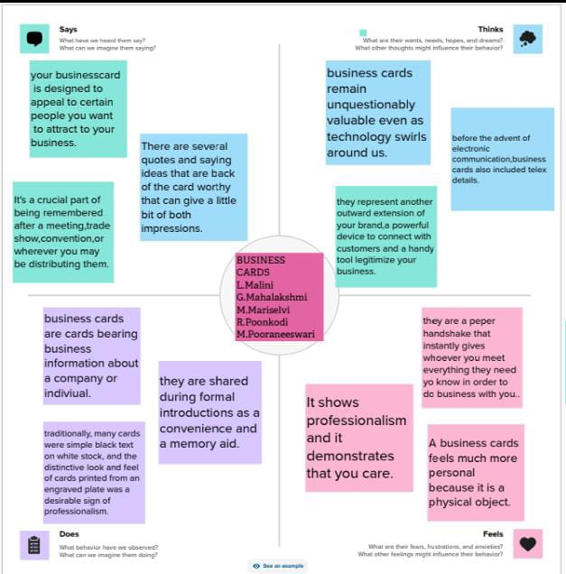

2.2 Brainstorm Map

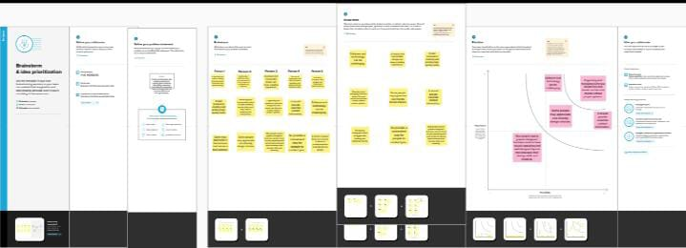

3. Result

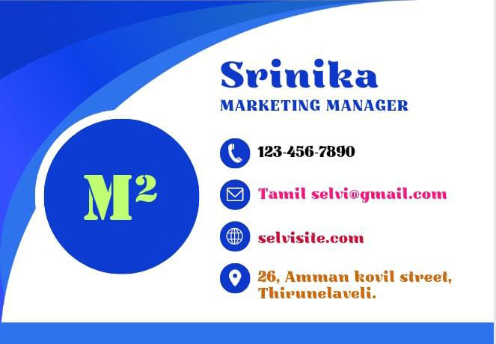

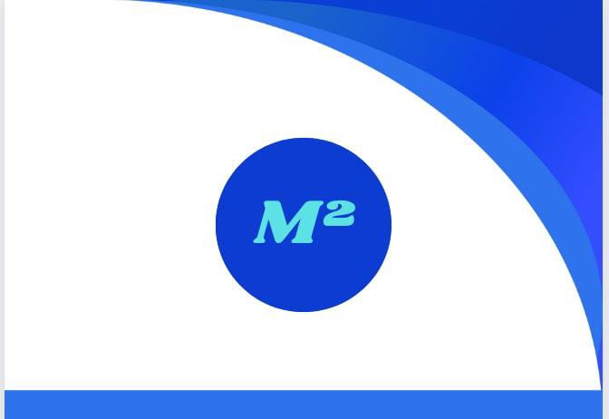

4.Advantages & disadvantages

## 1. Affordable way to promote your brand

[Cheap Business Cards](https://www.solopress.com/business-cards/economy/) can be bulk ordered for a relatively low cost. The number you print is flexible – vary the quantity depending on how many you’re likely to use day-to-day. Say you’re heading to a trade show one month, and you can increase your order at short notice.

It’s also cost-effective to print for multiple people but with different names – for example, your sales team.

## 2. Fantastic for events and exhibitions

Exhibitions and trade shows provide the perfect opportunity to promote your brand and build your contact base. Such events are perfect for meeting new contacts and making sales.

But often potential leads go away to think about whether to buy or take things further – this is where exchanging Business Card is invaluable, ensuring they have your contact details should they want to get in touch.

## 3. Something tangible – the business equivalent of vinyl records

People are increasingly favoring hard copies. Something they can hold and feel. Look at the rise in book sales and the [ongoing vinyl revival](https://www.theguardian.com/commentisfree/2017/nov/03/the-guardian-view-on-vinyl-getting-its-groove-back). Business Cards are part of this analogue renaissance.

They’re a little part of your brand people can take home – to pin on their fridge or stuff in their letter rack. Make it harder for people to throw them away with strong design and content that shows how your service can solve their problems.

## 4. Easy to distribute and display

Printed Business Cards can also act as a static display, where people can pick them up as they pass by.

Exhibit them anywhere, including:

* Store counter-top
* Pinned on an office notice board
* Held in a display holder

Ensure your name and company are visible when on display – think, is the right information above the fold? Thinking carefully about [what to include on a Business Card](https://www.solopress.com/blog/print-inspiration/12-things-to-include-on-a-business-card/) before it goes to print is time well spent.

**Disadvantages**

* Not Everyone Can Use It. A significant disadvantage of digital business card purchases is that many people are still not well-equipped to use them. ...
* A lack of personalization. Because you share such cards in digital format, paper cards' personal touch is wholly lost. ...
* Dangerous App> ...
* Requires Internet Access.

**5. Conclusion**

Digital business cards offer businesses and individuals a convenient and cost-effective way to save money when networking. You can quickly exchange contact information using digital business cards without relying on environmentally polluting printing.